Coding Lesson 1 - Output, Input and Variables

|  |
| --- |
| **Mild - perfect for beginners** |

1. Make the sprite say “**I love programming**”
2. Try the hide block - what does this do?
3. How did you get the sprite to reappear?
4. Display **“Welcome to Computer Science!”**
5. Input a word and Make the sprite say it on the screen three times.
6. Ask the user for their name and age. Make the sprite say: “**Hello [name]”**  then “**You are [age]**”
7. Click the sound menu - and try the **play sound** block.
8. Record a new sound for the Sprite to play. When recording and playing sounds, what is the output and what is the input?

|  |
| --- |
| **Medium - expanding your skills** |

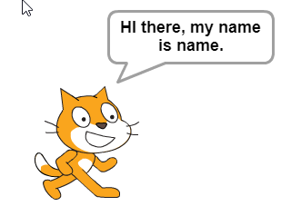

1. Add a second sprite and have them say hello to each other.
2. Input two words and have the sprite say them backwards.
3. Why is the variable name ***age*** better than ***x***?
4. What is wrong with the Scratch program to the right?:

1. Write the code to input a word and print it to the screen. What happens in the last problem if you type in a number instead of a word?

|  |
| --- |
| **Spicy - looking for a challenge?** |

1. Ask the user for their name and an adjective. Make the sprite say “**Hi there [adjective] [name], I am glad to meet you.**”
2. Ask the user to input two adjectives. Print "**The ___ pig is ___.**”
3. Input three words and have the sprite say them backwards.
4. Input your initials and print a monogram. My initials are RED and my monogram would be RDE.
5. Input a number and add 25. Have the Sprite say the answer.